**Datafile Addition in Tablespace**

1. Set the environment and execute the below script



1. Then It will Display the current Diskgroup Utilization as mentioned below,

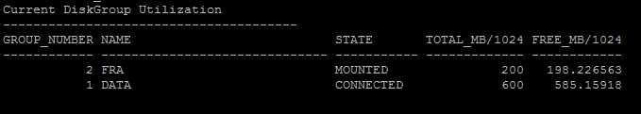

1. After that enter tablespace name in which we need to add datafile and DG Name which is having more freespace as mentioned below,

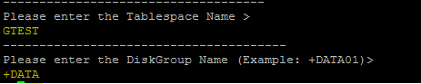

1. Once the datafile has been successfully added into the tablespace we will get a notification mail as mentioned below,

